# **Name: Abdurrahman Qureshi**

# **Roll No: 210451**

Practical No: 15

1) Create a class Employee with data members: name, department and salary. Create suitable methods for reading and printing employee information

CODE:

class Employee:  
 def __init__(self, name, department, salary):  
 self.name = name  
 self.department = department  
 self.salary = salary  
  
 def read_employee_info(self):  
 self.name = input("Enter employee name: ")  
 self.department = input("Enter department: ")  
 self.salary = float(input("Enter salary: "))  
  
 def display_employee_info(self):  
 print("Employee Information:")  
 print("Name:", self.name)  
 print("Department:", self.department)  
 print("Salary:", self.salary)  
  
emp = Employee("", "", 0)  
emp.read_employee_info()  
emp.display_employee_info()

OUTPUT:

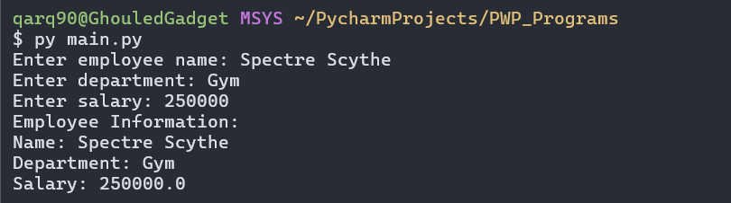

2) Python program to read and print students information using two classes using simple inheritance.

**CODE:**

class Person:  
 def __init__(self, name, age):  
 self.name = name  
 self.age = age  
  
  
class Student(Person):  
 def __init__(self, name, age, roll_number):  
 super().__init__(name, age)  
 self.roll_number = roll_number  
  
 def read_student_info(self):  
 self.name = input("Enter student name: ")  
 self.age = int(input("Enter age: "))  
 self.roll_number = input("Enter roll number: ")  
  
 def display_student_info(self):  
 print("Student Information:")  
 print("Name:", self.name)  
 print("Age:", self.age)  
 print("Roll Number:", self.roll_number)  
  
stud = Student("", 0, "")  
stud.read_student_info()  
stud.display_student_info()

**OUTPUT:**

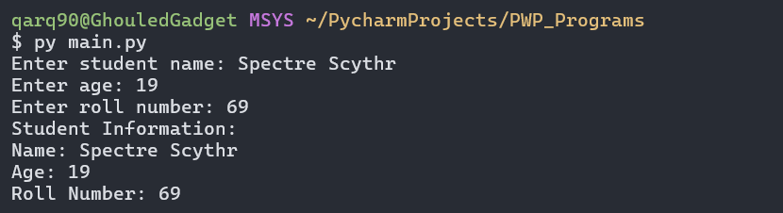

3) Write a Python program to implement multiple inheritance

**CODE:**

class A:  
 def method_A(self):  
 print("Method A in Class A")  
  
class B:  
 def method_B(self):  
 print("Method B in Class B")  
  
class C(A, B):  
 def method_C(self):  
 print("Method C in Class C")  
  
obj = C()  
obj.method_A()  
obj.method_B()  
obj.method_C()

**OUTPUT:**

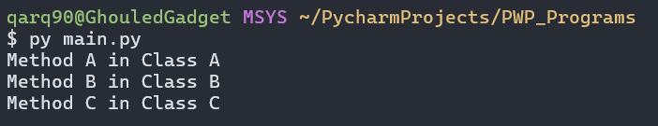

EXTRA QUESTIONS

4) Write a program to demonstrate use of multilevel inheritance.

**CODE:**

class Dadaji:  
 def method_Dadaji(self):  
 print("Method of Dadaji class")  
  
  
class Bapuji(Dadaji):  
 def method_Bapuji(self):  
 print("Method of Bapuji class")  
  
  
class Putr(Bapuji):  
 def method_putr(self):  
 print("Method of Putr class")  
  
  
obj = Putr()  
obj.method_Dadaji()  
obj.method_Bapuji()  
obj.method_putr()

**OUTPUT:**

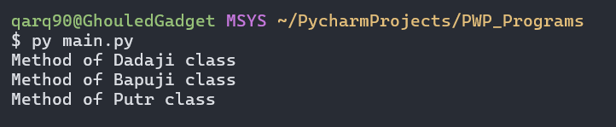

5) Write a python program to show the working of ierarchical inheritance.

**CODE:**

class J_A_A_N_W_A_R:  
 def jaanwar(self):  
 print("Animal bole mein ho jaanwar biro")  
  
  
class Kutta(J_A_A_N_W_A_R):  
 def bhao(self):  
 print("Dog bolta bhao bhao")  
  
  
class Billi(J_A_A_N_W_A_R):  
 def meow(self):  
 print("Cat boli meow meow")  
  
  
dog_obj = Kutta()  
cat_obj = Billi()  
  
dog_obj.jaanwar()  
dog_obj.bhao()  
cat_obj.jaanwar()  
cat_obj.meow()

**OUTPUT:**

